Applecross Senior High School

Semester One Examination, 2020

Question/Answer booklet

MATHEMATICS

SOLUTIONS
METHODS
UNIT 1

Section One:

Calculator-free

WA student number: In figures

In words

Your name

Number of additional
answer booklets used
(if applicable):

Time allowed for this section
Reading time before commencing work: five minutes
Working time: fifty minutes

Materials required/recommended for this section
To be provided by the supervisor
This Question/Answer booklet
Formula sheet

To be provided by the candidate
Standard items: pens (blue/black preferred), pencils (including coloured), sharpener,
correction fluid/tape, eraser, ruler, highlighters

Special items: nil

Important note to candidates
No other items may be taken into the examination room. It is your responsibility to ensure that you do not have any unauthorised material. If you have any unauthorised material with you, hand it to the supervisor before reading any further.

Structure of this paper

Section | Number of  questions  available | Number of  questions to  be answered | Working  time  (minutes) | Marks  available | Percentage  of  examination
Section One:  Calculator-free | 8 | 8 | 50 | 52 | 35
Section Two:  Calculator-assumed | 13 | 13 | 100 | 98 | 65
 |  |  |  | Total | 100

Instructions to candidates

1. The rules for the conduct of examinations are detailed in the school handbook. Sitting this examination implies that you agree to abide by these rules.

2. Write your answers in this Question/Answer booklet preferably using a blue/black pen.
Do not use erasable or gel pens.

3. You must be careful to confine your answers to the specific question asked and to follow any instructions that are specific to a particular question.

4. Show all your working clearly. Your working should be in sufficient detail to allow your answers to be checked readily and for marks to be awarded for reasoning. Incorrect answers given without supporting reasoning cannot be allocated any marks. For any question or part question worth more than two marks, valid working or justification is required to receive full marks. If you repeat any question, ensure that you cancel the answer you do not wish to have marked.

5. It is recommended that you do not use pencil, except in diagrams.

6. Supplementary pages for planning/continuing your answers to questions are provided at the end of this Question/Answer booklet. If you use these pages to continue an answer, indicate at the original answer where the answer is continued, i.e. give the page number.

7. The Formula sheet is not to be handed in with your Question/Answer booklet.
Section One: Calculator-free 35% (52 Marks)
This section has eight questions. Answer all questions. Write your answers in the spaces provided.

Working time: 50 minutes.

Question 1 (5 marks)
The point $M(-2, 5)$ is the midpoint of point $A(-6, 3)$ and point $B$.

(a) Determine the coordinates of point $B$. (2 marks)
Solution
$$\frac{-6+x}{2}=-2⇒x=2$$

$$\frac{3+y}{2}=5⇒y=7$$

$$B(2, 7)$$

Specific behaviours
correct $x$-coordinate
correct $y$-coordinate

(b) Determine the equation of the straight line that passes through point $C(4, -1)$ and is perpendicular to the line through points $A$ and $M$. (3 marks)
Solution
$$m_{AM}=\frac{5-3}{-2-(-6)}=\frac{1}{2}$$

$$m_{⊥}=-1÷\frac{1}{2}=-2$$

$$y-\left(-1\right)=-2\left(x-4\right) \\ y=-2x+7$$

Specific behaviours
gradient of $AM$
✓ perpendicular gradient
✓ correct equation

Question 2 (4 marks)
Expand and simplify the following.

(a) ${\left(x-9\right)}^{2}$. (1 mark)
Solution
$${\left(x-9\right)}^{2}=x^{2}-18x+81$$

Specific behaviours
correct expansion

(b) $(2x+1)(x-3)(x+7)$. (3 marks)

Solution
$$\left(2x+1\right)\left(x-3\right)\left(x+7\right)=\left(2x+1\right)\left(x^{2}+4x-21\right) \\ =2x^{3}+8x^{2}-42x+x^{2}+4x-21 \\ =2x^{3}+9x^{2}-38x-21$$

Specific behaviours
correct binomial expansion
✓ correct full expansion
✓ simplifies correctly

Question 3 (5 marks)
Functions $f$ and $g$ are defined by $f\left(x\right)=4x^{2}-4x+5$ and $g\left(x\right)=2x^{2}-8x+6$.

(a) Determine the discriminant of $f$ and the discriminant of $g$. (2 marks)
Solution
$$Δ_{f}={\left(-4\right)}^{2}-4\left(4\right)\left(5\right)=-64$$

$$Δ_{g}={\left(-8\right)}^{2}-4\left(2\right)\left(6\right)=16$$

Specific behaviours
discriminant of $f$
discriminant of $g$

(b) State, with justification, which function has no zeros and determine all zeros of the other function. (3 marks)
Solution
$f$ has no zeroes as $Δ_{f}<0$.

$g\left(x\right)=0$ when
$$x=\frac{-\left(-8\right)±\sqrt{16}}{2\left(2\right)} \\ x=2±1$$

$g$ has zeros when $x=1, x=3$.

Specific behaviours
states $f$ has no zeroes
✓ indicates appropriate method to find zeros
✓ both zeros of $g$

Question 4 (7 marks)
(a) Sketch the graph of $y^{2}=x$ on the axes below. (2 marks)
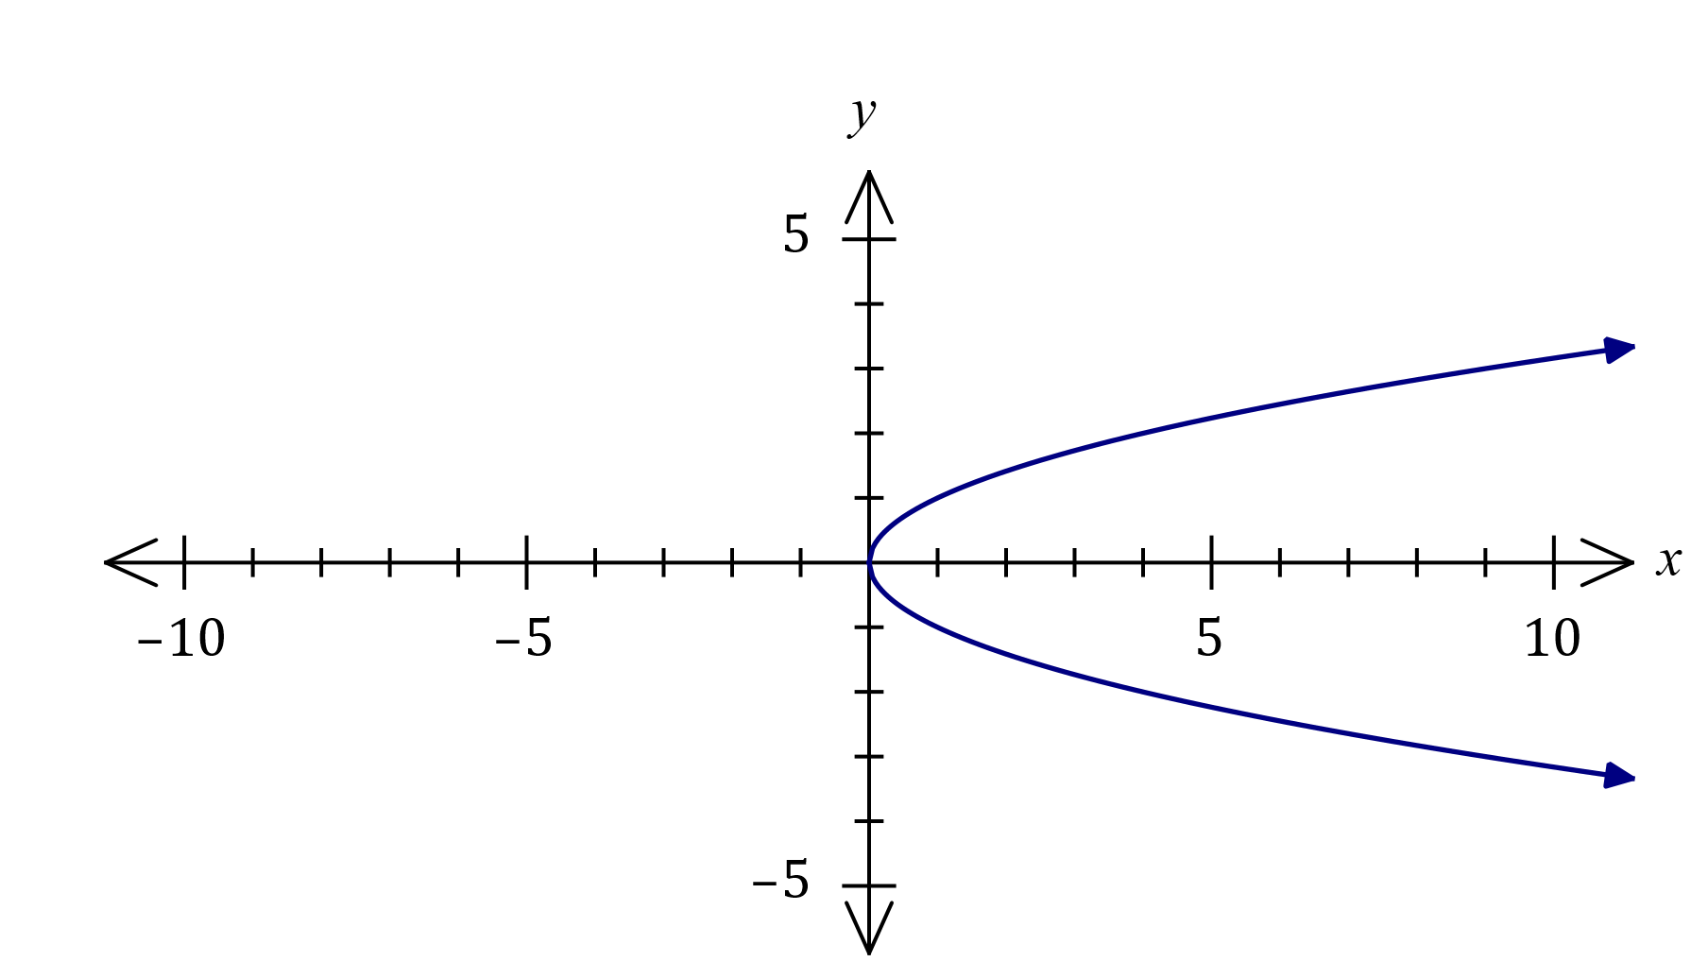
Solution
See graph
Specific behaviours
location of vertex
✓ symmetric parabola

(b) Sketch the graph of ${\left(x+1\right)}^{2}+{\left(y-1\right)}^{2}=4$ on the axes below. (3 marks)

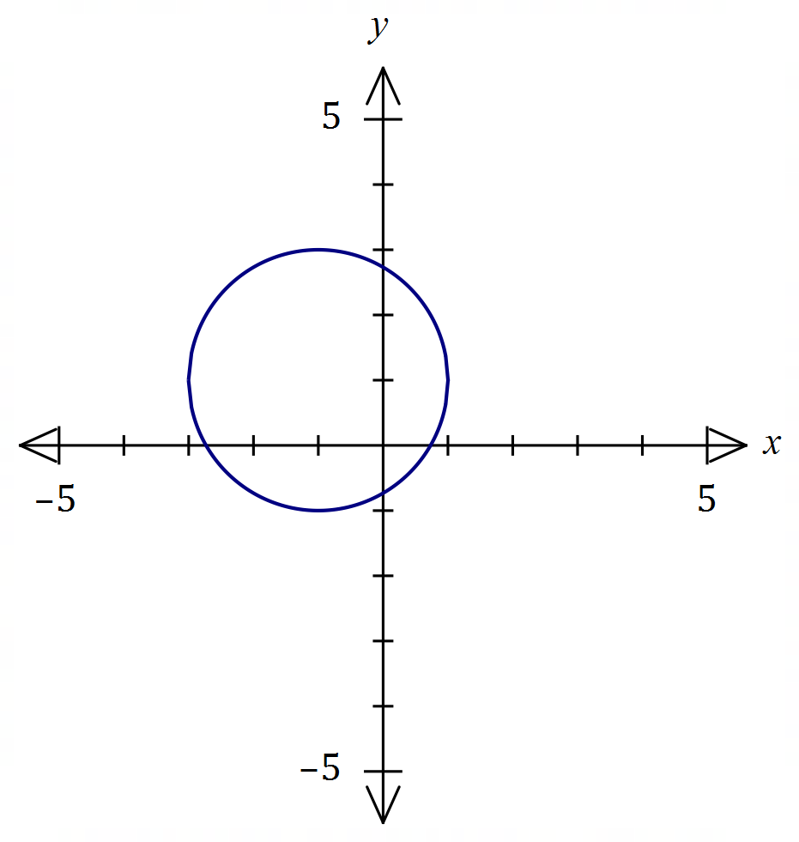
Solution
See graph
Specific behaviours
location of centre
✓ correct radius
✓ smooth circle

(c) Explain whether $y$ is a function of $x$ in the relationship graphed in (a). (2 marks)
Solution
$y$ is NOT a function of $x.$This is because the graph of the relationship fails the vertical line test.

Specific behaviours
states not a function
✓ explanation (VLT, one-to-many, etc)

Question 5 (8 marks)
(a) A periodic function is defined by $f\left(x\right)=2-2\sin{(3x)}$.

(i) State the amplitude of the function. (1 mark)
Solution
Amplitude is $2$.
Specific behaviours
correct amplitude

(ii) State the period of the function in degrees. (1 mark)
Solution
Period is $360÷3=120°$.
Specific behaviours
correct period

(iii) Sketch the graph of $y=f(x)$ on the axes below. (3 marks)
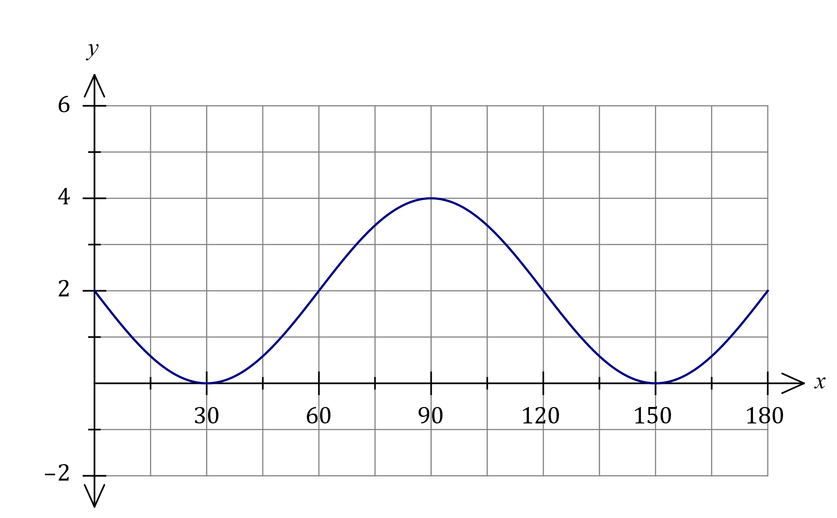
Solution
See graph
Specific behaviours
$(0, 2)$ and $(180, 2)$
✓ locates turning pts
✓ smooth curve

(b) Solve the equation $2\cos{(x-15°)}=\sqrt{3}$ where $0≤x≤360°$. (3 marks)
Solution
$$\cos\left(x-15°\right)=\frac{\sqrt{3}}{2} \\ x-15°=30°, 330° \\ x=45°, 345°$$

Specific behaviours
determines an angle for $\frac{\sqrt{3}}{2}$
✓ determines one solution
✓ both correct solutions

Question 6 (7 marks)
(a) The variable $V$ is inversely proportional to the variable $t$, so that when $t=3.6$, $V=10$.

(i) Explain how $V$ will change as $t$ increases. (1 mark)
Solution
As $t$ increases $V$ will decrease.
Specific behaviours
correct explanation

(ii) Determine $t$ when $V=3$. (2 marks)
Solution
$$V×t=k⇒k=3.6×10=36$$

$$3t=36⇒t=12$$

Specific behaviours
indicates appropriate method
✓ correct value

(b) Part of the graph of $y=\begin{matrix}a \\ \overline{x+2}\end{matrix}$ is drawn below.
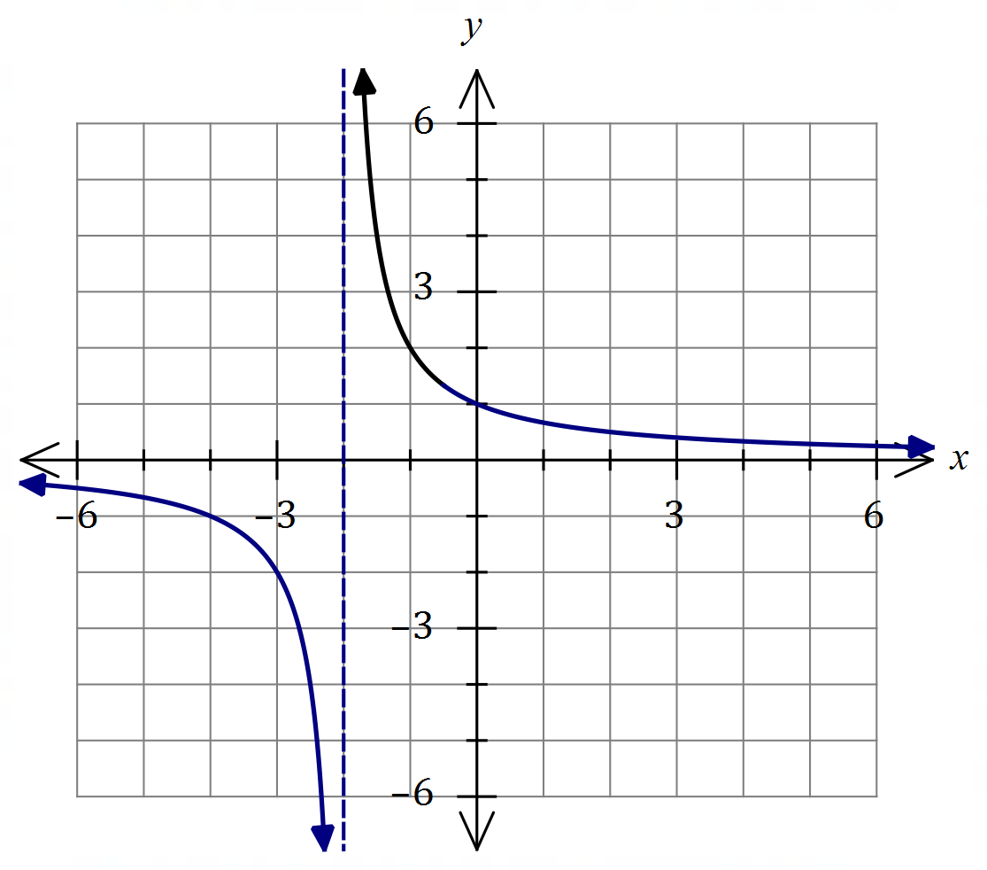
Solution (b)(ii)
See graph
Specific behaviours
asymptotes
✓ thru' $\left(0, 1\right), \left(-4, -1\right)$
✓ two smooth curves

(i) Determine the value of $a$. (1 mark)
Solution
$$\left(-1, 2\right)⇒2=\frac{a}{-1+2}⇒a=2$$

Specific behaviours
correct value

(ii) Draw the remainder of the graph. (3 marks)

Question 7 (8 marks)
Solve the following equations for $x$.

(a) $x^{2}+20x-21=0$. (2 marks)
Solution
$$x^{2}+20x-21=\left(x-1\right)\left(x+21\right)$$

Hence $x=1, x=-21$.

Specific behaviours
factorises
✓ states both solutions

(b) ${\left(x-1\right)}^{2}-4=2x-3$. (3 marks)
Solution
$$x^{2}-2x+1-4=2x-3 \\ x^{2}-4x=0$$

$$x\left(x-4\right)=0$$

$$x=0, x=4$$

Specific behaviours
expands and equates to zero
✓ factorises
✓ states both solutions

(c) $x^{3}-2x^{2}-11x+12=0$. (3 marks)

Solution
$$x^{3}-2x^{2}-11x+12|_{x=1}=13-13=0$$

$$x^{3}-2x^{2}-11x+12=(x-1)(x^{2}-x-12) \\ =(x-1)(x+3)(x-4)$$

$$x=-3, x=1, x=4$$

Specific behaviours
indicates linear factor
✓ factorises
✓ states all solutions

Question 8 (8 marks)
(a) Determine an exact value for $\cos{103°}\cos{58°}+\sin{103°}\sin{58°}$. (2 marks)
Solution
$$\cos{103°}\cos{58°}+\sin{103°}\sin{58°}=\cos\left(103°-58°\right) \\ =\cos{45°} \\ =\frac{\sqrt{2}}{2}$$

Specific behaviours
uses double angle formula
✓ states exact value

(b) Determine all possible values of $\tan{θ}$ when $\sin{θ}=\begin{matrix}2 \\ \overline{3}\end{matrix}$ (3 marks)
Solution
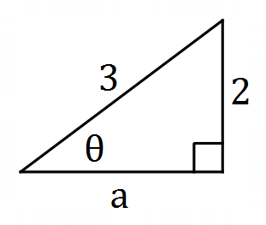
$$a=\sqrt{9-4}=\sqrt{5}$$
Note that $θ$ can be in quadrant $1$ or $2$.
$$\text{In Q1:}\tan{θ}=\frac{2}{\sqrt{5}}, \text{in Q2}\tan{θ}=-\frac{2}{\sqrt{5}}$$

Specific behaviours
relevant use of right triangle
✓ one correct value
✓ both correct values

(c) Determine an exact value for $\sin{75°}$. (3 marks)

Solution
$$\sin{75°}=\sin\left(30°+45°\right) \\ =\sin{30°}\cos{45°}+\cos{30°}\sin{45°} \\ =\frac{1}{2}×\frac{\sqrt{2}}{2}+\frac{\sqrt{3}}{2}×\frac{\sqrt{2}}{2} \\ =\frac{\sqrt{2}+\sqrt{6}}{4}$$

Specific behaviours
uses double angle formula
✓ uses correct exact values
✓ simplifies to obtain final value

Supplementary page

Question number: _________

© 2020 WA Exam Papers. Applecross Senior High School has a non-exclusive licence to copy and communicate this document for non-commercial, educational use within the school. No other copying, communication or use is permitted without the express written permission of WA Exam Papers. SN002-152-3.

